Experiment 3 M. Devarajulu
Aim 192212058
To solve the water jug problem using Python Program.
Algorithm
- Start.
- Define the capacities of two jugs and the target amount.
- Create an empty set to store visited states.
- Start with both jugs empty (0,0).
- Check possible operations:
  - Fill a jug.
  - Empty a jug.
  - Pour water from one jug to another.
- Store each new state and avoid repeated states.
- Continue generating states until the target amount is reached.
- If the target is found, display the solution.
- If no state reaches the target, display "No solution exists."
- Stop.

Program
# Water Jug Problem

from collections import deque

def water_jug(jug1, jug2, target):
visited = set()
queue = deque([(0, 0)])

while queue:
x, y = queue.popleft()

if (x, y) in visited:
continue

visited.add((x, y))
print((x, y))

if x == target or y == target:
print("Target reached!")
return

queue.extend([
(jug1, y), # Fill Jug 1
(x, jug2), # Fill Jug 2
(0, y), # Empty Jug 1
(x, 0), # Empty Jug 2
(x - min(x, jug2 - y), y + min(x, jug2 - y)), # Pour Jug 1 -> Jug 2
(x + min(y, jug1 - x), y - min(y, jug1 - x)) # Pour Jug 2 -> Jug 1
])

Output:

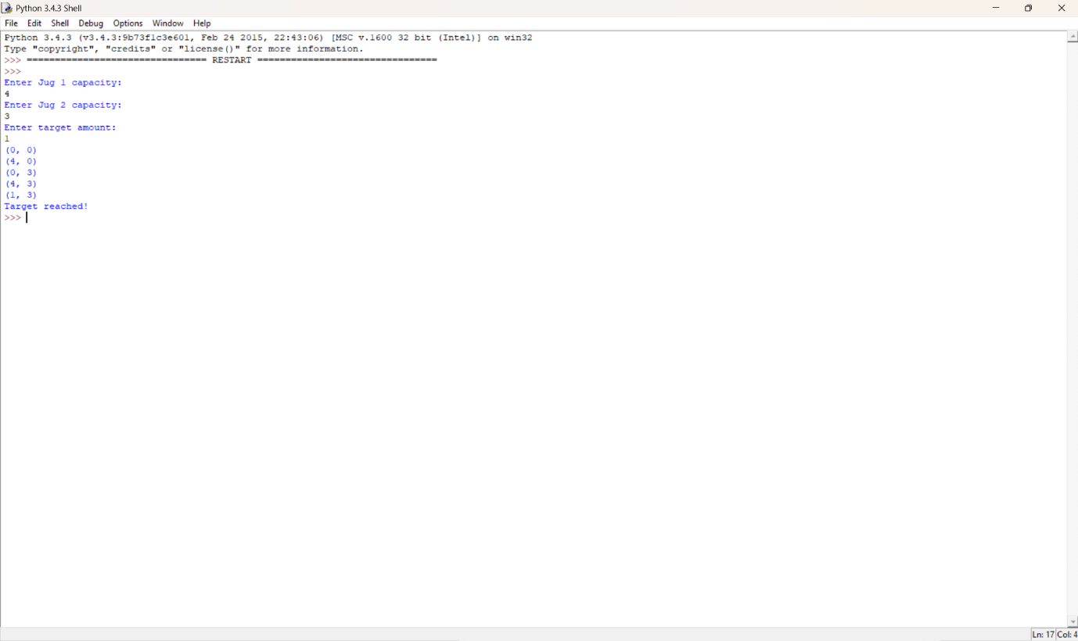

Result:

The final state (1, 3) means:
- Jug 1 contains 1 liter
- Jug 2 contains 3 liters
Thus, the target of 3 liters is successfully measured.

